|  |
| --- |
|  |
| **Inception and Elaboration Phase**  Assignment 2 Lecturer -Dr. **Thair Al-Dala'in** |
| |  |  |  | | --- | --- | --- | | RASMAN SURENDER MUKESH KUMAR ID-11693040 | 4/4/21 | ITC508 Object Modelling | |

Table of Contents

Inception Phase 2-6

Elaboration Phase 6-13

Last week or week 7 we dercibed system architecture, or the design

Design the system, descripe ocmpaontntes

Same case study

Jjustify the design

If possible add more architecture diagrams

Task 2 choose 2 use cases fro m2st assignment and use story boards

Design UI for the 2 usecases

Task 3

Drill down report

Expaiend last week im think week 6 wor 7 8

Also expain one drill down report

**Inception phase**

**System vision document**

**IDINE**

* ***Project Introduction***

A restaurant business runs exceptionally well when customer needs are met as well as it has appetising food. But in certain times due to large crowd few restaurants get into poor customer management. A restaurant named “VALLEE DE GOUT” which is a French cuisine situated in outer suburbs of Sydney has maintained great quality standards also offering deluxe experience of fine dining. But during weekends they are getting overcrowded and it has affected sales, customer service and management.

It is crucial for a restaurant to provide quality service and manage even when its overcrowded. I and our team observed day to day operations, gathered data from the main users like department managers, waiters, teams and cooks. Analysis of this data, made us to come with a new information system “iDine”.

This system has multiple subsystems:

* Customer order Management
* Inventory management system
  + Automated stock control
  + Pantry management
  + Fresh produce management
* Sales Analytics Management.
* Customer feedback management.

It is also suggested that the restaurant should deploy the new information system “iDine” to take their quality maintenance , dining experience and customer management to next level.

* ***Important system capabilities***
* Gathering and storing data of customer orders, time spent in restaurant since order to payment and customer feedbacks.
* Gathering and storing data of stock orders and receiving updates
* Gathering and storing data of supplies, and details of supplier
* Gathering and storing data reasons for order cancels, order changes.
* Allows users to play games.
* Connection and transmission of data via WIFI
* Allows to show various charts for sales, orders, inventory, menus, feedback and supplies.
* Allows to call waiter to order manually.
* Collected of all sorts of data which are useful in generating reports and charts
* Provides preparation estimated time and this is acknowledging customer when the order is complete.
* Provides wait-time and queue time estimation to manage customers when its overcrowded.
* Provides real-time space availability and updates in the company website.
* ***Perceived Business benefits***
* Maintain and track accurate data of orders, cancelled orders and changed orders.
* Maintain and track accurate data of customers, customer orders, time spent in restaurant and feedbacks.
* Maintain and track accurate data of stock like in-stock and out of stock details.
* Maintain accurate data of inventory and supplies.
* Increase in customer engagement.
* Easily manage customers overcrowded over the weekend and other weekdays.
* Easily accessible and fast order processing.
* Increase in sales and maintain proper inventory.
* Increase in Customer satisfaction.
* Increase in customer feedback which will help the business in updating the restaurant system and significant changes can be done based on customer feedback.
* ***Resources required***
* TableTop Tablets for each table for letting the customer to order.
* Tablet in the cooking area to view and manage orders.
* Tablets for the head waiters
* Internet (WIFI) connection
* Tablet holders
* Tablet cleaning equipment
* Data Storage
* A special purpose computer with a small display at exit door for feedback
* ***Stakeholder map***

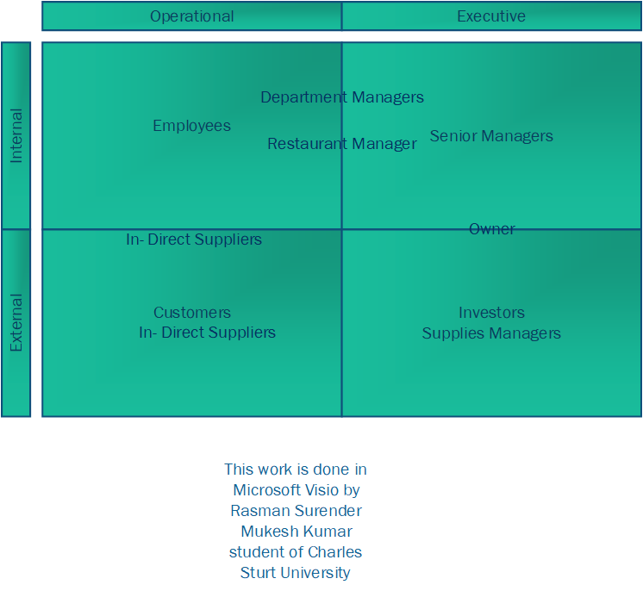

**Elaboration phase:**

* Identify use cases and draw use case diagram(s) for the new information system that shows major use cases and actors.

Major use cases:

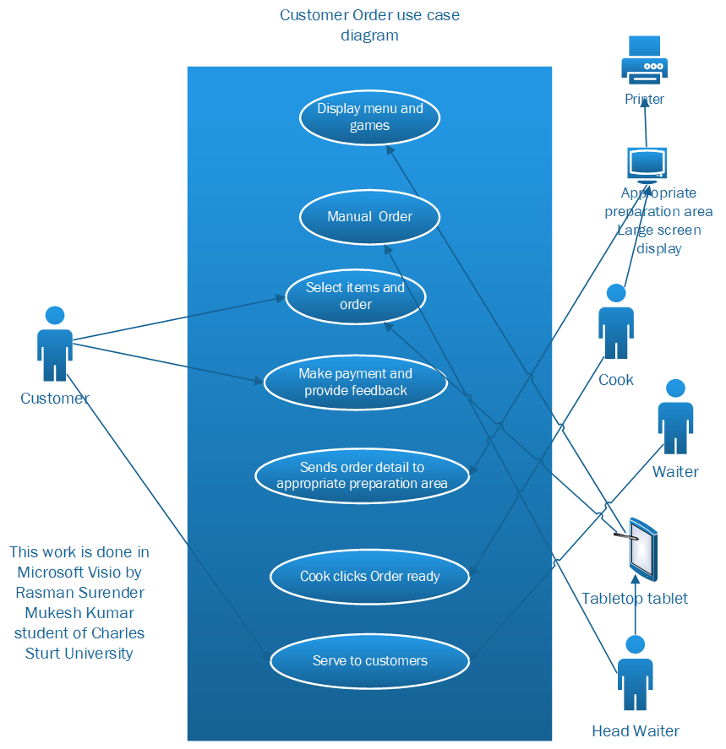

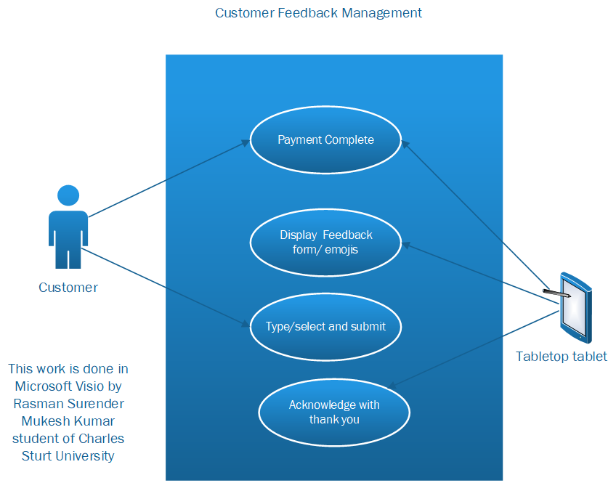

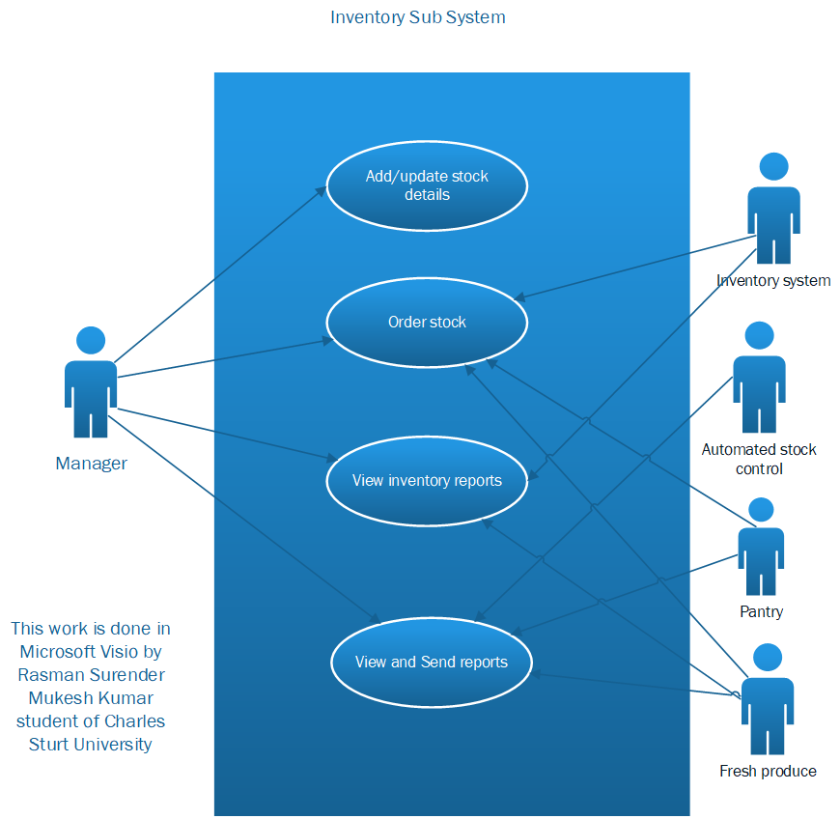

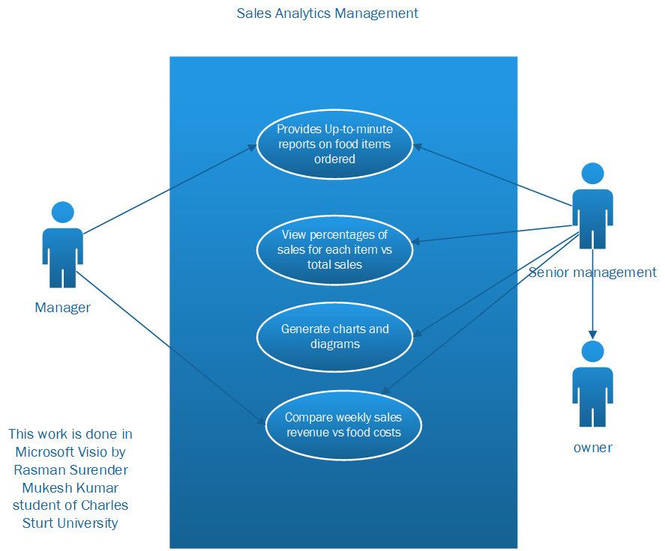

* Write one fully developed use case description for one of the important use cases identified. Select an important use case that is a key part of the system, not a basic simple one.

|  |  |  |
| --- | --- | --- |
| Use Case Name: | Customer order | |
| Scenario: | Customer orders food | |
| Triggering Event: | Contractor wants to eat delicious food and have a luxury fine dining experience. | |
| Brief Description: | A customer wants to eat delicious food. Customer needs hassle free ordering. Customer expects luxury fine dining experience. | |
| Actors: | Customer, cook, waiter, head waiter, tabletop tablet, printer and appropriate preparation area large screen display. | |
| Stakeholders: | Customer  Employees  Restaurant Manager  Department managers | |
| Preconditions: | Customer must exist in the store or view seat availability in company website  Customer must make an order.  Inventory items must exist. | |
| Postconditions: | New order is created  Order list is printed  Order preparation is initiated.  New sale is made.  Inventory is updated | |
| Flow of Activities: | Actor | System |
| 1. customer views displayed menu.  2. Customer makes an order.  3. Customer makes payment  4. Customer gives feedback  5. System sends order information to respected preparation areas.  6. waiter gets notified when the order is ready.  7. waiter serves the dish to the respected customers tables based on the table number on order receipt. | 1.1 System displays menu lists based on popularity.  1.2 System update items in inventory, displays price, adds to total.  3.1 System calculates total and displays amount to customer for making payment.  4.1 System displays feedback form and acknowledges when form is submitted.  5.1 System displays order details in preparation areas.  6.1 System send notification when the order is ready and cook confirms it.  7.1 Waiter carries the item from the preparation area to serve the customers. |
| Exception Conditions: | 1 If any ingredient or item is out of stock in the inventory, it is updated and displayed as out of stock and provides alternative options for customers on the tabletop tablet screen.  2 If customer orders item 1 instead of item 2, then customer can click the button call waiter. This notifies the head waiter and sends the waiter near the table to update the order.  3. If company website is down, then they can contact the restaurant via mobile to know table availability  4 If any item is damaged or broken or food is roasted, then it can be considered under damaged stock.  5 If any customer’s handwriting is not properly structured and readable, the system will automatically auto correct it. | |

* Draw the UML domain model class diagram(s) for the new information system. Be as specific and accurate as possible, given the information provided. If needed information is not provided, make realistic assumptions.

